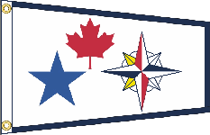 Cascadia

Together Once Again Sail-In

Poulsbo, WA

October 22nd - October 24th 2021

Coordinator:
Fill in the blanks and email to the event coordinator
- Your name __
- Your email address __
- Your phone number __
- Your boat's name __
- The number of people coming with you [ ] and their names for nametags.
__
__
__
__
__
__
- Whether you are sailing or driving to the sail-in
[ ] Sailing [ ] Driving
- If you are sailing
  - Boat overall length __
  - Boat beam __
  - Docking preference __
(Bow in or Stern in or no preference)
(Starboard tie or Port tie or no preference)
  - 30’ or 40’ Slip __ (Over hang is allowed)
- Where you are coming from __
- When you expect to arrive to the sail-in __
- When you expect to leave the sail-in __
- Any comments and suggestions you have for the sail-in
__
__
__
__

